**SMART PUBLIC RESTROOM ALGORITHM USING IOT**

# Introduction

IoT brings more changes to the life of humans and increases the quality of life [1] by in- regrating Artificial Intelligent (AI) and cloud computing [2,3]. In recent trends, the Internet of Things (IoT) is considered to be the more attractive and revolutionary technology that plays a vital role in various fields such as healthcare, house automation, smart cities [4,5],

**WORKING ALGORITHM**

**Algorithm 1** MFB-FA: Modified Flashing Behavior-based Firefly Algorithm

Input : Size of the population

Output : Best optimal solution (bestsubset)

Begin

set params for Modified_FA(); initpopulation;

Det of light intensity_I();

Object(fun) = f(q), q = (q1, . . . , qd)T

Generate an initial chaotic population of fireflies

qi, i = 1, 2, . . . n

compute the ′I′ so that it is associated with f(q) while(T Max Iteration)

≤

Define absorption coefficient β with chaos Gaussian Map

for m = 1 : i (i ff) for n = 1 : i (i ff) if Im *>* In

move ff towards n; end if

2

Vary attractiveness withdistance Dist via exp−βDist

Evaluation of new solutions and updating of light intensity (LI)

end for end for

Firefly ranking and determination of best solution;

T = T + 1 end

**Algorithm 2** MANN-AM (Modified Artificial Neural Network with Attention Mechanism)

Input : Input : dataset df, xtrain, xtest − independent variable, ytrain, ytesttarget variable Output : target ypreds with tract infection of UTX_DIAGONSIS(0, 1)

scale the datasets using // input layer

divide xtrainxtest and ytrain, ytest //input layer

W is calculated based on dist using //hidden layer

set value for parameter k

Estimating the distance between train and test Sorting dist in an ascending pattern

select the best kneigh

Repeating steps 2–4 until the algorithm is over W matrix is saved as result

Simulation involves using //hidden layer Saving results

Retrieving ANN with attention model

Setting values for number of input, output and hidden layers

Primary weighing of existing neurons in input, output and hidden layers Calculating the output (y) for each neuron in output layer

Updating ANN parameters

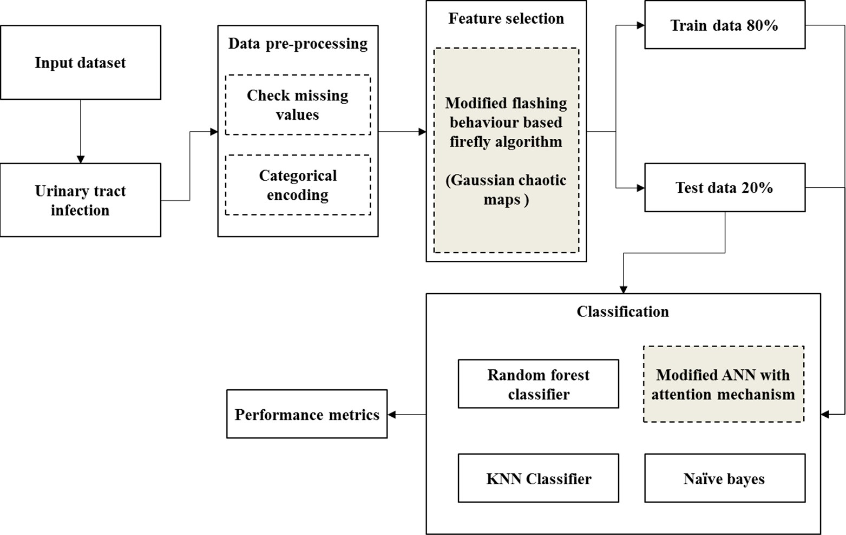**SYSTEM LOGIC**: